TargCC

Target Code Creator User Manual



Ver 4.0.5.50
Table of Contents
What is TargCC? 6
Basic Principles 7
Defining Factors 7
5 Tier 7
Database 7
Controller Functions 7
Object Functions 7
Collection Functions 7
Web Service 8
Windows Forms 8
Data Flow Diagram 9
Authentication 9
Error Handling 9
Enums and Lookup Tables 9
Localization 10
Source Control 10
Maintenance 10
How to use TargCC 11
Installing TargCC 11
Starting Out 11
The Database 11
The Solution 11
Project Nomenclature 12
Compile Options 13
Setting Up (All about TargCC’s screens) 14
Solution 16
Database Details for TargCC 16
Solution Components 16
Security 17
Database Details for Application 17
Application Access 17
Roles & Permissions 18
Database 18
Expose Row Changers 18
Initialize Database 19
Auditing Procedures 19
User Table 19
Appearance 20
Colours 20
Forms Model 21
Grid Updates 21
Double Click in Table Row Creates Popup 21
System Entity Design (ctl_c_) 21
Templates 22
File Templates 22
Generic Data 22
Results 23
Tools 24
Getting your Solution Up & Running 24
Stored Procedures 24
_Dependencies 24
Using Visual Studio Solution Explorer, Click on ‘Show All Files’ 24
DBController 24
DBStdController 25
TaskManager 26
WS 26
WSController 27
WSStdController 27
WinF 28
Custom WinForm Projects 29
Hint 29
First Run 30
The Authentication Model 31
Application Authentication to the Web Service 31
Specific User Credentials 31
Active User Credentials 31
Application Credentials 31
None 31
User Identification Model 31
By Domain User 31
By Domain Group 31
By Application User 32
None 32
Notes 32
Understanding Permissions 33
Processes 33
Permissions 33
PermissionsByIdentity 33
Reasoning 33
Users and Roles 33
Roles 33
Applications 34
Monitoring Data Changes and Access 34
Auditing 34
Data Access 34
How TargCC Transforms the Database into an Application 35
Tables 35
Prefix ‘c_’ 35
Default Text Fields 35
Views 35
Fields 35
Prefix ‘eno’ 35
Prefix ‘ent’ 35
Prefix ‘FUI_’ 35
Prefix ‘enm’ 36
Prefix ‘lkp’ 36
Prefix ‘loc’ 36
Prefix ‘clc_’ 37
Prefix ‘blg_’ 37
Prefix ‘agg_’ 37
Prefix ‘spt_’ 37
Combined Prefixes 37
Suffix ‘ID’ 37
Primary Key 37
Image fields 37
Extended Properties 37
Date Added 38
Relationships 38
Indexes 38
Entity 38
Collection 38
Windows Client 39
Overview 39
The Object Control 39
String Length 39
The Collection Control 39
String Length 39
How to work with the code created by TargCC 40
Business Logic 40
Working with an Object 40
Appendix 1 – Using a View to Create the Class 41
General 41
Create the View 41
Create the Indexes 41
Create the Data 42

What is TargCC?
TargCC (Target Code Creator) is a system that creates a 5-tier database application, complete with authentication, logging and error handling.

Basic Principles

Defining Factors
The system is entirely dependent on the structure of the database. It takes into account the field names and properties. In addition, it creates functions based on the indexes and foreign key relationships.

5 Tier
- Database
- DB Controller
- Web Service
- WS Controller
- Client (Windows Forms)

Database
TargCC creates all the stored procedures to service the functions below.

Controller Functions
The server-side and client-side controllers are similar. The server-side controller (DB Controller) accesses data from the database, while the client-side controller (WS Controller) accesses data from the Web Service.
Aside from the functions below, the DB Controller is expected to handle the system’s business logic.
The DB Controller is also responsible to ensure that only permitted users access the functions.

Object Functions
- GetByXXX (Unique Indexes, with or without one-to-one children and parents)
- Update – updates all properties that are changeable by the client
- UpdateFriend – updates all properties, including those only changeable server-side (used to ensure business logic fields are safe)
- UpdateAggregates – updates counters or aggregate fields. Can only by updated server side
- UpdateSeparateXXX – updates a specific field. Can be updated at the client or the server. Used where different permissions are needed (for example, a comments field that can be updated by anyone, in the “TopSecret” object.)
- Delete
- FillXXX (one - many relationships)
- LoadDependantParents
- LoadOneToOneChildren
- Clone
- ToString – overloads ToString and creates a human readable list of all the objects’ properties
- ToCSV – Creates a comma delimited row of all properties, to be used by the collection in creating a CSV file.
- IsEqual – compares each property in two objects to see if they are equal

Collection Functions
- Fill
- FillByXXX (non-unique indexes)
- FillByBoundedXXX (non-unique indexes, From XX To XX)
- FillByWildCardXXX (Indexed Strings – unique and non-unique)
- FillOnTheFly (by any index, bounded and wildcarded)
- FillSumOnTheFly (by any index, grouped by any index, bounded and wildcarded)
- Clone
- CloneByXXX
- CloneByBoundedXXX
- CloneByWildcardXXX
- FindByXXX (unique indexes)
- LoadDependants (loads parents and one-to-one children)
- SortByXXX (all columns)
- ToCSV – creates a CSV string of the collection
- ToString – Creates a human readable list of all rows in the collection

Web Service
The Web Service exposes a proprietary API.
The proprietary API is as secure as a standard Web API, if not more. It is also must faster and has a smaller payload.
However, with the proprietary API, you client will be required to use the WS controller.

Windows Forms
- Creates default controls for objects and collections
- Creates panels for each object and its children
- Automatically creates and fills comboboxes for foreign keys
- Creates default Login and Splash screens

Data Flow Diagram
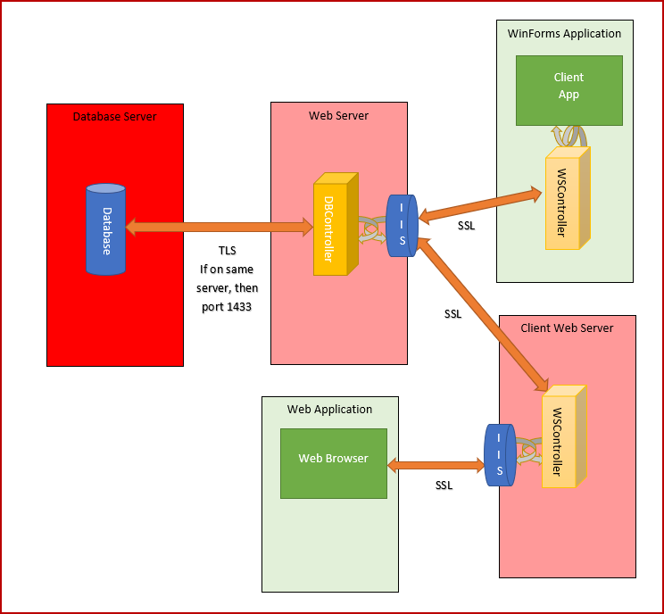

Authentication
The system creates tables and controls for maintaining Roles and Users. These users can be independent, or linked to Active Directory.
The roles are assigned execute rights to each of the processes (functions) exposed by the system.
Additional roles can be created, to which specific permissions can be assigned.

Error Handling
Error Handling is intrinsic to the system. All errors and alerts, both client side and server side, are logged to the database. They can then be viewed and acted upon.

Enums and Lookup Tables
TargCC creates enums for those lookups that you want to refer to in code. This greatly simplifies coding your business logic. For example if pPerson.Status = enmStatuses.Happy then etc.
For those cases where you don’t need an enum, you can save the creation of additional tables by using TargCC’s Lookup table.

Localization
Applications written by TargCC can target up to multiple languages. Multi-Language support is available for Error Messages, Enums, and Lookups.
In addition, all fields are automatically offered for localization.

Source Control
It is recommended to use Team Foundation Server for Source control. Source Safe (and possibly others), rely on making files read-only, which TargCC does not support.

Maintenance
The system creates a console application that can be used to run various tasks on the server. This application is called the TaskManager. It is activated by the Windows Task Manager. Certain default tasks are already created. They can be used as a template for application-specific tasks.

How to use TargCC

Installing TargCC
TargCC is designed to be run from within Visual Studio. Follow the steps below to install it.
- Create a Batch File
- Create a batch file with the following text (including the quotes):
"%AppData%\Microsoft\Windows\Start Menu\Programs\Target Systems\Target Tools\TargCC.appref-ms" %1
- Save the file as TargCC.bat, wherever you like.
- Define in Visual Studio
- In Visual Studio, click on: Tools --> External Tools
- Click on "Add"
- In Title, type "T&argCC" (no quotes)
- In Command, choose the batch file you created above.
- In Arguments, type (or choose) "$(SolutionDir)DBController " (no quotes)
- Choose "Close on exit"
- Choose "Use Output window"
- Choose Apply, then OK
- Run from within Visual Studio
- After opening your solution, click on Tools --> TargCC
- Enjoy! Note that you can only run the 'Update', if the program is registered.

Starting Out

The Database
Create a blank database.

The Solution
Create a new solution. After creating the 1st project (below), save the solution to disk. Take care to choose a meaningful Solution Name.
If you don’t see the solution name when you have only one project, then set the following in Visual Studio options:
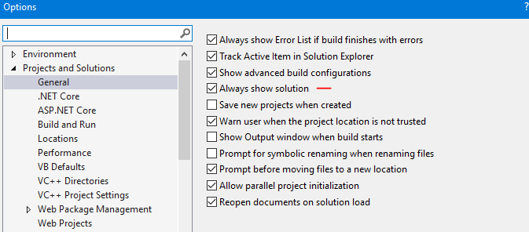
Create the following projects in the solution (note: all TargCC projects are Visual Basic):
- DBController – a Class Library (.Net Framework)
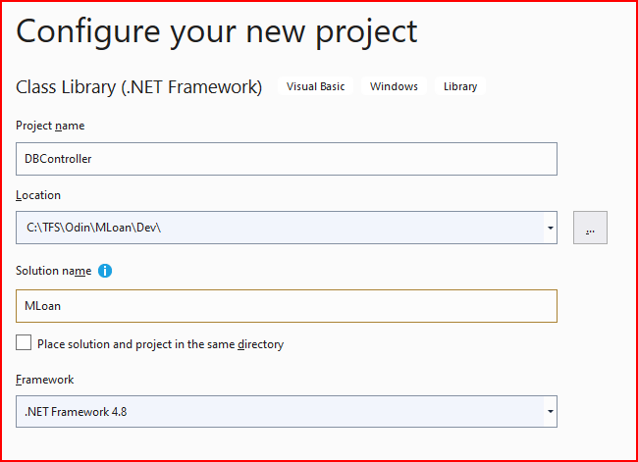
- Delete Class1.vb
- DBStdController - Class Library (.Net Standard 2.0 (2.1 is not useable by Framework))
- Delete Class1.vb
- TaskManager – a console application (.Net Framework)
- Delete Module1.vb
- WS – a Web Service application
- add an ASP.Net Web Application (.Net Framework)
- Choose empty, and ensure all the rest is not clicked (you can allow the HTTPS, but only adds overhead if developing locally).
- WSController - Class Library (.Net Framework)
- Delete Class1.vb
- WSStdController - Class Library (.Net Standard)
- Delete Class1.vb
- WinF - Windows Forms App (.Net Framework)
- Delete Form1.vb
- _Dependencies – a Shared Project
- Used to store solution specific dll’s. etc.

If you are using Source Control, then add it to Source Control at this point. Check everything in then check everything back out.

Project Nomenclature
Assign the Assembly name and Root namespace to each of the projects. These should have the solution name prefixed to the Project name. Also, change “Controller” part of the Root Namespace for each of the controllers to DataController. See the example below:
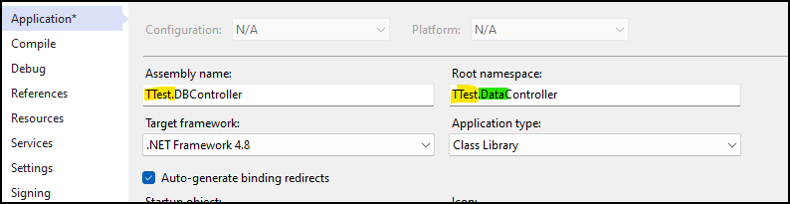

Compile Options
Ensure that Option Strict is on for all the projects.
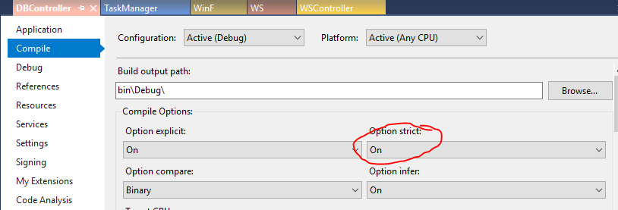

Setting Up (All about TargCC’s screens)
First, open TargCC from within Visual Studio.
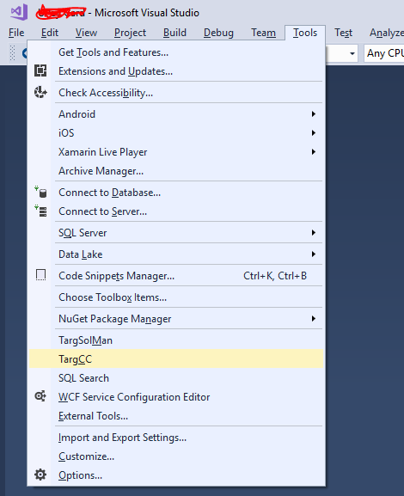
Once it opens, it creates a new settings file.
Include the new file as part of the DBController project:
Show all files:

Include in project
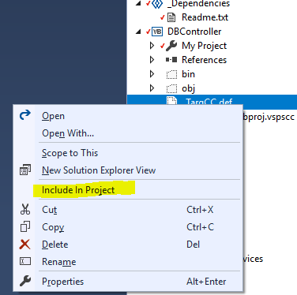

Then perform the following action on each of the tabs

Solution
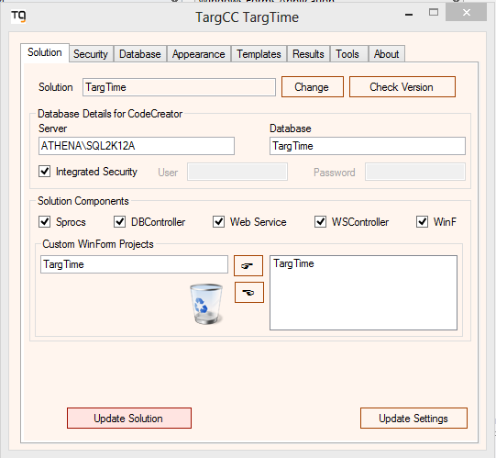
In the solution tab, define the database location and the parts of the solution.

Database Details for TargCC
Define the database server and database name. If not using integrated security, add the credentials for SQL Server. Note that these are the credentials used for development – not the credentials to be used when running your developed application. Once done, click on ‘Update Settings’.

Solution Components
Choose the solution components that you want the Code Creator to update. In addition, choose Sprocs (Stored Procedures) if you want it to create or update the stored procedures. If you have any custom WinForm projects, add them to the list. (More on custom WinForm projects later).

Security
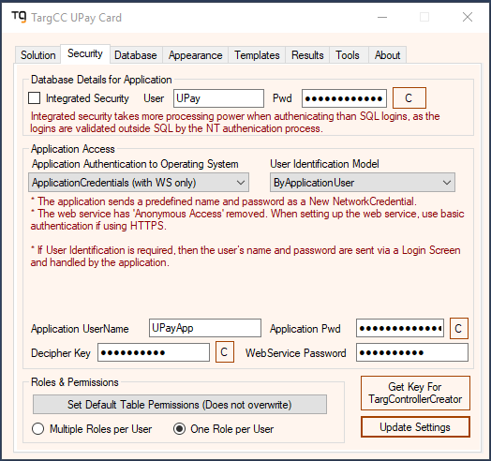
In the Security tab, define the various security parameters to be used by your application when it is run.

Database Details for Application
This is where you set the credentials to be used by your running application. Define the method to be used by the Web Service (via DBController) when interacting with the Database.

SQL authentication is recommended, if possible. Integrated Security takes more processing power when authenticating than SQL logins as the logins are validated outside SQL by the NT authentication process. After typing in the UserName and Password, you can put them in the clipboard by clicking on ‘C’. Note that you can create a secure password using the Tools tab. After you’ve decided on a user name and password, create the SQL user in SQL Server via SSMS

Note that Integrated Security is may be more secure (depending on your setup) since the password is not stored in TargCC or the config file. (Note that the password is stored encrypted, but can be found by clicking on “C”.)
In either case, assign the user to a Database role membership of 'public'. After that,run the following (where DBName and UserName are replaced with the appropriate values) :
USE DBName
GO
GRANT EXECUTE TO UserName
GO
GRANT BACKUP DATABASE TO UserName
GO

Application Access
Define the authentication method to be used by the WinForms client against the Web Service.
In addition, define whether the user’s identity is required to be defined as well. For more information, see ‘The Authentication Model’, below.
(If you defined the User Identification Model as ‘ByApplicationUser’, then when you first run your new system, login with the username 'Admin' and password 'password'.)
Now define the application’s domain username and password (if ‘ApplicationCredentials’ was chosen.
Note that Application Authentication will be ignored if the WS is behind a WAF (such as Cloudflare).
Create a Web Service password (used by the Web Service Client when accessing the Web Service), or accept the random password that was created.
Finally, choose the Decipher Key which is used for all two-way encryption throughout the program, or accept the random password that was created.
In order to get the values needed to set up the server, click on ‘C’

Roles & Permissions
If this is the 1st time you are running TargCC, and the database tables have not yet been created, “Set Default Table Permissions” will not work. You use this after adding roles or tables to an existing database.
- Note that a user can only be assigned one role. His permissions are defined by the role

Database
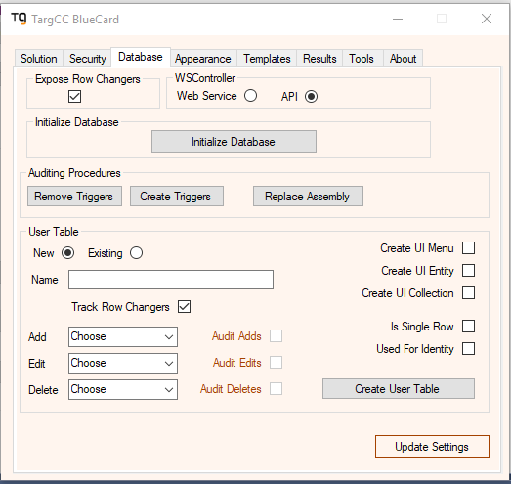

Expose Row Changers
By default, the tables do not expose the fields:
- Added By
- Added On
- Changed By
- Changed On
They are stored in the database for auditing purposes.

If you would like them exposed in the .NET class, then choose the check box.

Initialize Database
At this point, click on Initialize Database and follow the instructions. This will create the system tables required for the solution.

Auditing Procedures
Each of the tables that are audited requires a trigger that calls the audit routines. Using these 3 buttons you can remove the triggers (If you have data maintenance that you want to perform and auditing is unnecessary overhead), create the triggers on any tables that should have them but don’t, or replace the assembly (the code called by the trigger).
Click on Replace Assembly to install (or replace) the auditing assembly.

In SQL Server 2017 and above, you’ll may need permissions to run the auditing DLL in SQLCLR. You can run the appropriate query from the template:
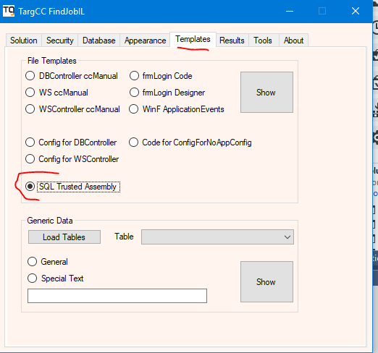

User Table
This creates and updates user tables with the minimal fields required, based on the choices made.
"Track Row Changers" means that the table has auditing fields (AddedBy, AddedOn, ChangedBy, ChangedOn, etc.). When you choose “Audit Edits, etc.”, these fields are sent to the Audit table. Otherwise, only the last change is known.
You can define if functions will be created for Add, Edit and Delete for the table in only the DBController (server-side), or all levels (including the Web Service, WSController and WinF projects)
Creating a User Table adds or updates an entry in the ‘c_Table’ table.
Once you’ve created your tables, add your fields. After that, set the default fields manually in c_Table.
Functionality can be added to your properties by using specific nomenclature for your fields. For more details, see the section “How TargCC Transforms the Database into an Application” “Fields”.
Now manually create all the indexes and relationships that you’ll need. Note that Primary Fields can consist of one field only.
In order to maintain an existing table, choose the “existing” radio button and then choose the table from the combobox. Note that only tables listed in c_Table are found in the ComboBox.
In the Defaults WinForms project, each table creates a menu entry, an entity screen and a collection grid.
The following checkboxes define what will be shown in the custom WinForms project: ‘Create UI Menu’, ‘Create UI Entity’ and ‘Create UI Collection’.
‘Is Single Row; lets you define a table will that will have only one row. It will not have a primary key, and will not get a UI Collection grid.
“Used for Identity“ is used to define a table that can be used to describe a user type. For example, if customers are assigned users, and distributors are assigned users, then the Customer table and Distributor table would be defined as ‘Used for Identity’. This would automatically like the user’s access to only objects belonging to the customer or distributor.

Appearance
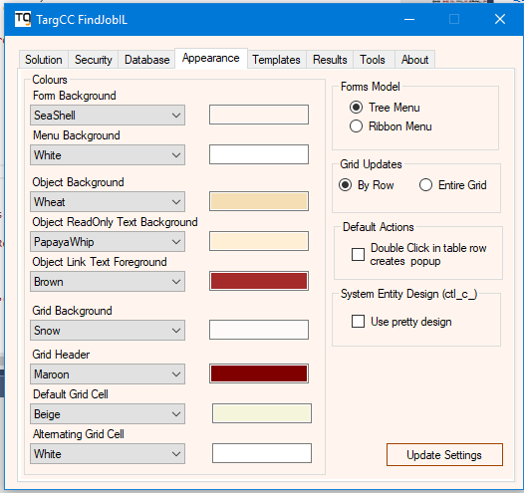

Colours
This is where you choose the basic colours.

Forms Model
The Windows Forms application can have two menu types
- Tree Menu – this puts a tree menu on the left-hand side of the form
- Ribbon Menu – this puts a menu at the top of the form.

Grid Updates
There are 2 methods available for updating grids: By row and entire grid.
The preferred method is to update the grid by row (similar to the way table view works in Access and SQL Management Studio).
The other option is by entire grid. This is similar to the way Excel works.

Double Click in Table Row Creates Popup
By default, if you double-click on a row in a grid, the entity screen for the item is called via a series of event handlers.
If this option is chosen, a popup will appear with the entity’s details.

System Entity Design (ctl_c_)
If you choose this, then key entity controls will have a functional design. If not, then the properties will be shown in the default (list of properties) method.

Templates
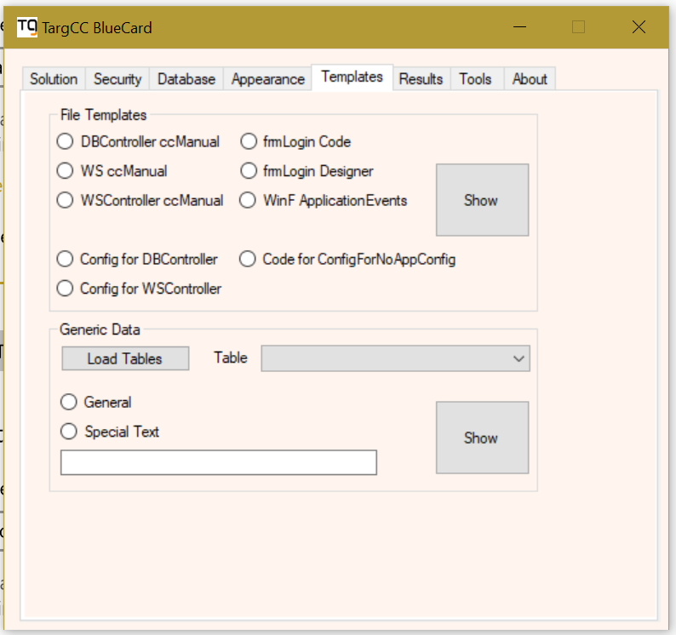

File Templates
In this section you can get the templates for those files that are created only once, at the start of the project (in case you screwed something up and you want a clean copy).
You also get the code that you should add to the Web Config of the Web Service, and the App Config of the Client.
Note that if you want the client to access DBController directly (without traversing the web service), then use config for DBController. You may also need a row or 2 from the Winf Appconfig template. You’ll see for yourself when you try it out

Generic Data

General
If you choose a table and click on this, you will get all the information you can think of about the table.

Special Text
This section can save you a great deal of time. If you choose a table and then write some text, the text will be copied once for each property. The ‘~’ symbol will be replaced with the property. You can use this to create any repetitive code you might need. Note that only tables listed in c_Table are found in the ComboBox.

Results
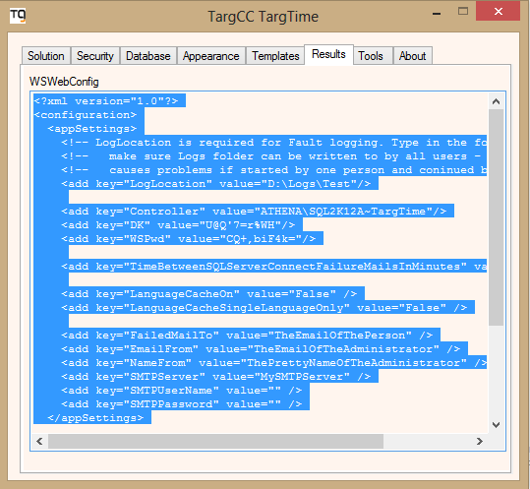
This is where TargCC gives you the information you request.

Tools
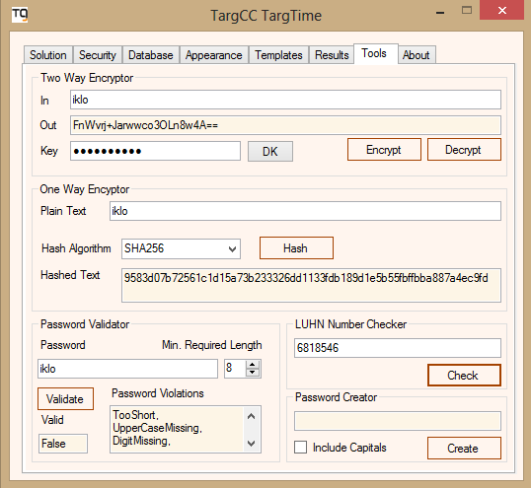
This is where various encryption tools can be found.

Getting your Solution Up & Running
By this point, you’ve created your tables, indexes and relationships. You’ve also created the system tables as well as a skeleton for the solution.
Now it’s time to jump in and actually use TargCC.

Stored Procedures
- Run TargCC. In ‘Solution Components’, choose ‘Sprocs’.
- Then click on ‘Update Solution’.
- Some errors may occur, if you didn’t define indexes correctly, etc. Fix them and then try again.
- TargCC has now created all the Stored Procedures.

_Dependencies

Using Visual Studio Solution Explorer, Click on ‘Show All Files’
Select all the files except the ‘vspscc’ file, and right-click ‘Include in Project’. Now, of those, click on the exe, pdb and dll files, the right-click and “Add to Source Control”

DBController
In ‘Solution Components’ of TargCC, choose ‘DBController’.
Then click on ‘Update Solution’.
Using Visual Studio Solution Explorer, Click on ‘Show All Files’
Right Click on the CC folder and choose ‘Include in Project’.
Do the same for:
- _TutorialConfig.config
- _TutorialController.vb
_TargCC.def (the definition file) was done in a previous step.
In References, add a reference to:
- System.Configuration
- System.Drawing
- System.IO.Compression.FileSystem
- System.Management
- System.Transactions
- If the project includes the SMS Module, then from the _Dependencies folder, add a reference to TargetSMS019.dll
- Check it in Imported Namespaces as well
- Add Newtonsoft.Json via the NuGet Package Manager. (If you like, you can add it to WSController, DBStdController and WSStdController at the same time)
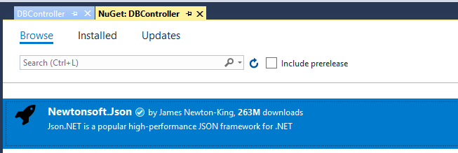
Now compile DBController. Any ‘Errors’ that still show at this point are probably due to:
- incorrect indexes
- incorrect foreign keys
- improperly defined enums
- missing actual lookups

Make any changes and run TargCC again (you can run both the sprocs and DBController simultaneously).
Once you have no errors, compile the project. You are ready to go on.
Note that if you created lookups, but don’t yet have data for it, then add one for Undefined

DBStdController
If you want to reference the DBController in a .Net Core project, then use the DBStdContoller, which is compiled for .Net Standard. If not, the you can Unload or even Remove the project
When you created the code for DBController, you created the code for DBStdContoller at the same time.

Using the NuGet Package Manager, add
- Microsoft.Win32.Registry B
- System.Configuration.ConfigurationManager B
- System.Drawing.Common - B
- System.Data.SqlClient – DBController Only
- System.Management - B
- System.Diagnostics.EventLog – DBController only
- System.Diagnostics.PerformanceCounter – B
- Newtonsoft.Json - B

In Imported Namespaces (Project Properties Reference Tab), add :
- System.Data

TaskManager
When you created the code for DBController, you created the code for TaskManager at the same time.
Using Visual Studio Solution Explorer, Click on ‘Show All Files’
Right Click on the CC folder and choose ‘Include in Project’. In the root, add ‘app.config’ to the project
In References, add a reference to:
- the DBController project
- Assign the Imported namespaces, where XXX is the solution name:
- XXX.DataController

In ‘Properties’ --> ‘Settings’, define the Application Username and password that the TaskManager will be running under. We suggest the user ‘LocalTaskManager’. Create the user in WinF, once it’s created. Give it ApplicationMaster rights, as well as rights to access TaskManager.
- add JobRunner (String) as an Application Setting. This is the user name you’ll create later on used to run the job (‘LocalTaskManager’, if you go by my suggestion)
- add Pwd (String) as an Application Setting. Create a secure password via the Tools tab of the CodeCreator.
- add AlwaysOn (Boolean) as an Application Setting. The default is True
- 'AlwaysOn means that the TaskManager is run once and stays up. 'Otherwise, it is activated at regular intervals by the Task Scheduler
- Add DelayOnStartUpSec (integer) as an Application Setting. This defines the delay before starting to work (useful to not overload the server on reboot)
- Add IsOneOfACouple (Boolean) as an Application Setting. The default is False
- Set to True if 2 TaskManagers on 2 different servers are working against the same database (for redundancy). If one goes down, the other one will automatically become active
- Add WriteToEventLog (Boolean) as an Application Setting. The default is False
- Set to True if you want it to write to the Windows Event Log

In Properties Application
- Choose sub Main as the startup object

Add the connection data to the App.config file
- See the _TutorialConfig.config file in the DBController project for instructions
- You must set “LogLocation” and “Controller”
- All other configuration settings will be taken from the database, unless you override them in the config file.
- If you have to know about SQL startup failure, then I recommend that the mail server info be kept in the config. If not, then it will get the mail server data from the database.

WS
Now let’s create the web service.
Back in TargCC, in ‘Solution Components’, choose ‘Web Service’.
Then click on ‘Update Solution’.
Using Visual Studio Solution Explorer, Click on ‘Show All Files’
Right Click on the CC folder and choose ‘Include in Project’. Also include the files
- Global.asax
- _Tutorial.asmx
- _Tutorial.vb
- ForgotPassword.aspx
In References, add a reference to:
- the DBController project
- Assign the Imported namespaces, where XXX is the solution name:
- XXX.DataController

Add connection data to web.config from the template in DBController’s _TutorialConfig.config file. Change the value for LogLocation as needed
Compile and run WS (run ccAPI.aspx). Note the URL it was given.

WSController
In ‘Solution Components’, choose ‘WSController’.
Then click on ‘Update Solution’.
Using Visual Studio Solution Explorer, click on ‘Show All Files’
Right Click on the CC folder and choose ‘Include in Project’. Then add:
- _TutorialConfig.config
- _TutorialController.vb

In References, add a reference to:
- System.Configuration
- System.Drawing
- System.IO.Compression.FileSystem
- System.Management
- Add Newtonsoft.Json via the NuGet Package Manager, as in the DBController above

WSStdController
If you want to reference the WSController in a .Net Core project, then use the WSStdContoller, which is compiled for .Net Standard. If not, the you can Unload or even Remove the project
When you created the code for WSController, you created the code for WSStdContoller at the same time.

Using Visual Studio Solution Explorer, click on ‘Show All Files’
Using the NuGet Package Manager, add
- Microsoft.Win32.Registry
- System.Configuration.ConfigurationManager
- System.Drawing.Common
- System.Management
- Newtonsoft.Json

In Imported Namespaces (Project Properties Reference Tab), add :
- System.Data

WinF
Now we do the Windows Client!
In ‘Solution Components’, choose ‘WinF’.
Then click on ‘Update Solution’.
Using Visual Studio Solution Explorer, click on ‘Show All Files’
Right Click on the CC folder and choose ‘Include in Project’.
Now include al files starting from ‘ApplicationEvents.vb’ and ending at the file ‘TargetSmall.jpg’.
In References, add a reference to:
- WSController
- System.Configuration
- Assign the Imported namespaces, where XXX is the solution name:
- XXX.DataController

In ‘Properties’ --> ‘Settings’,
- add Language (String) as a user setting and set to ‘en’ as default.
- add LocalizedTextLanguage (String) as a user setting and set to ‘en’ as default.
- add Culture (String) as a user setting and set to ‘en-US’ as default.
- add WindowMaximized (Boolean) as a user setting and set to ‘False’ as default.
- add WindowLocation (System.Drawing.Point) as a user setting and set to ‘0,0’ as default.
- add WindowsSize (System.Drawing.Size) as a user setting and set to ‘0,0’ as default.
- add GridInfo (String) as a user setting and leave it blank as default.
- Add DefaultUserFileLocation (String) as a user setting and leave it blank as default.
- Add FontSize (Single) as a user setting and leave it to 10 as default.
- Add SplitterLocation (Integer) as a user setting and leave it to 150 as default.
- add IsLocalized (Boolean) as an application setting and set it to True or False, depending on your requirement.

In Properties Application
- Choose frmMain as the startup form
- Click on View Application Events. Note that TargCC’s Application events file was already created by TargCC. By clicking on it, you ensure the application uses it.
- Click on ‘make single instance application’ if you want only one instance of the application to be opened at a time on the user’s computer

In Properties Compile
- Remove ‘Prefer 32-bit’ if you want a 64 bit application

Now select the default Target graphics:
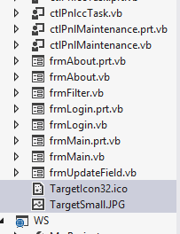

Set them to a ‘Build Action’ of ‘Content’ and a “CopyTo..” of ‘Copy if Newer’
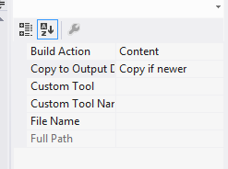
Add the connection data to the App.config file, from the Templates tab of TargCC. Use the Config for WSController template (since we are accessing the database via the web service).

Custom WinForm Projects
This is the actual project that you will be distributing to your users. In this project, the some of the designer files and all the ‘prt’ files are not overwritten.
In WinF, everything is overwritten so that if you add any fields, you can copy the appropriate controls from there to your custom projects.
The following types of files are not overwritten in the custom project
- Entity Designer
- *.prt.vb files

Add a custom WinForm project to the solution. You can leave the Assembly and Root namespace as they are (you don’t have to add the Solution name as a prefix). Delete Form1.vb.
Follow all the instructions is in WinF above.

Hint
In designing the entities, create an invisible panel control called pnlGarbage and put controls for any properties that you don’t want shown into it. (if you delete the control, it will result in an error).
In designing collection (grids) and panels, remove any controls that you don’t want seen in the .prt.file.
Eg.lblxx.Parent.Controls.Remove(lblxx)

Adding new fields to the WinFormControl
In the ctlcc, to add the variables for which errors are received as follows:.
- Use Intellisense to create the variables, replace As Object with the correct type, and turn the buttons into WithEvents.
- Compile the admin.
- Open (in Designer) the ctlcc.
- Comment out the variables added in section 1.
- Copy the controls from WinF to the admin. If you don't want to see them, put them in pnlGarbage.
- Compile the admin.

First Run
There should be no problems running the solution locally.
Note that when you publish the solution and do an initial restore of the development database, you may get a “principle dbo” error or something similar. In this case please run the following on the server, replacing XXXX with the database name:
ALTER AUTHORIZATION ON DATABASE::XXXX TO sa;

The Authentication Model
The Authentication model is based on a combination of authentication and identity.
For maximum security, the Web Service should be protected, i.e., it should have anonymous authentication removed from at least ccAPI.aspx and CC.asmx. This means that no one can browse the available functions. The client application requires credentials in order to access it.
In actuality, the entity being authenticated is the client application. The client app can pass the user’s workstation login credentials or application credentials defined by the developer.
User authentication (if required) is done via the workstation credentials sent, or by a name/password combination handled by the application.
The user’s identity can either be ‘Global’ or an entity instance. For example, the user’s identity could be ‘Head Office’ (Global) or Montreal Branch (entity – branch, instance – Montreal)
Below are the various model combinations:

Application Authentication to the Web Service
Application authentication can only be used if the client is accessing a web service.

Specific User Credentials
The user’s name and password are sent via a Login Screen as a New ‘NetworkCredential’. The Web Service has 'Anonymous Access' removed. (This might be used if accessing a server from outside the domain)
The database is accessed with the user’s rights if integrated security is used by the Web Service.

Active User Credentials
The user's credentials are sent as a ‘NetworkCredential’. The user does not enter a name/password combination. The Web Service has 'Anonymous Access' removed. (This is used for accessing a server from within a domain, using the logged in user’s credentials.)
The database is accessed with the user’s rights if integrated security is used by the Web Service.

Application Credentials
The application sends a predefined name and password (taken from the app.config) as a New ‘NetworkCredential’. The Web Service has 'Anonymous Access' removed.

None
The web service has 'Anonymous Access' enabled. Anyone can then scan the functions exposed by the Web Service or try to access the page.

User Identification Model

By Domain User
The user is identified within the system by the domain user’s User Name in active directory. The User Name must also be defined in the User table of the system (via the User screen).
This cannot be used when Authentication is via Application Credentials.

By Domain Group
The user is identified within the system by the user’s group in active directory. The domain group must be defined as the User Name in the User table of the system (via the User screen).
The domain group acts as a kind of “fake user” for the purposes of permission control. When logging accesses and changes, the user’s UserName is recorded
This also cannot be used when Authentication is via Application Credentials

By Application User
The user’s name and password are sent via a Login Screen and handled by the system.

None
If you do not want to define a user, then define the model as “By Application User”. Create a fake user and log in automatically via the fake user name. Ensure that this fake user is allowed multiple log-ins.

Notes
If you are using https (and you should be), remove integrated windows authentication and allow basic authentication for better performance if sending newly created credentials when setting up the web service. It avoids a round trip. To be specific, remove integrated windows authentication for Specific User Credentials and Application Credentials, and ensure it exists for Active User Credentials.
If not using https, then ensure you are using windows authentication so that the password is not sent as clear text.
If you want to pass the credentials to the next level (say, a web to a web service), then you must add impersonate=true to the upper level (the web in our example).

Understanding Permissions
Permissions are defined for each process (function) exposed by the DBController. In order to ensure security, it is recommended that you add your business logic functions as new classes in DBController (as opposed to creating a new assembly).
Automatic permissions (‘tbl’ and ‘viw’) are also checked at the WSController level to avoid a round trip.

Processes
Processes are defined in the c_Process table. Note the prefix tbl_=Table, viw_=View, prc_=Procedure.
The tbl and viw entries are handled automatically - don't add to them yourself.
When writing a function manually in DBController add it to the process table with the “prc_” prefix.

Permissions
The permissions table lists all possible choices of Processes and Roles.
Verification of permissions is done at the DBController level

PermissionsByIdentity
If a table is defined as “Used For Identity” and the user has this identity then his access is limited to himself and his children.

Reasoning
DBController is a closed object. There are two types of functions that a user can access:
- the standard Get, Update, Delete for each entity and collection
- business logic functions written by the programmer

The standard functions have their permissions set by the user's role and identity, as described above. They have the "tbl_" or "viw_" prefix
The problem is with the Business Logic Functions. A user may have permissions to access the function, but may not have permissions to access the functions that the function itself has to access in order to perform its task. Therefore, these are handled differently.
Each of these functions is entered in the c_Process table with a "prc_" prefix.
On entering the function from outside the DBController, the user's Requester object’s EntryFunction property (a "friend" property that cannot be accessed outside DBController) is assigned the FunctionName.
The permissions are then checked using the "GetPermissionsForExternal" function of the ccSecurity object. If the user has permission, then all is OK. Now each time the user enters any of the standard functions, the permission check is bypassed, since the EntryFunction property is not empty. This enables us to do any business logic without giving a user specific access to a table.
Just to be sure, if the user encounters a fault, then the property is emptied in the Fault object

Users and Roles
Each user is assigned a username. The username is assigned to one or more roles.

Roles
Roles define the rights the user has. It also defines the user’s right to access an application.
There are 6 intrinsic roles:
- Master – this role should be used sparingly. Users assigned this role should be protected by a very strong password. Users with this role bypass all security checks, and can access all applications. It is not logged, for speed
- ApplicationMaster – this role should be used sparingly. Users assigned this role should be protected by a very strong password. Users with this role bypass all security checks. However, it is checked for Application permission. It is not logged, for speed
- Administrator – this role has full control of all non-user management tables
- User Manager – this role has full control of all user-management tables
- SysAdmin – this role has full control of all tables
- User – this role has read-only access to all non-user management tables

New roles can be created at will and permissions assigned to specific tables. When creating a new role, you can assign initial permissions based on an existing row in the Permissions tab (System Maintenance Permissions). Fine tuning is done in the Permissions tab of the process table tab (System Process Permissions).

Applications
In order to access an application, a user must be assigned to the application. The is done in the User screen, Security tab.

In summary, when accessing the DBController from the outside, both the user’s role and his application assignment are checked (the latter inly if not a Master).

Monitoring Data Changes and Access

Auditing
When creating a table in the database, you can assign the level of auditing you’d like.
By default, all fields are audited unless:
- You set the field’s extended property of ccDNA, as described above

To improve performance, the Audit is written to the SystemAudit table, which is not meant to be used directly. The Task Manager scans it at regular intervals and move the information to the AuditIndexed table, which can be accessed directly and also via the WinF application

Data Access
If LogRequests is set to True in the System Default table, then:
- every request to the DBController from the outside is logged.
- Users in the Master and ApplicationMaster roles are NOT logged.

How TargCC Transforms the Database into an Application

Tables

Prefix ‘c_’
The prefix ‘c_’ denotes a System Table. These are tables created by the Code Creator to perform its tasks and maintain itself.

Default Text Fields
The tables default text fields are defined in c_Table. The default field is used when representing a data row from the table in the child or the parent.
The field can be formatted. Use ’;’ to split between the fields’ collection and the format. Use # to split between the fields. In the format replace the fields with {0}, {1} etc (in order).
For example: FirstName#LastName;Hello {0}. Your last name is {1}. Wow!
This would return “Hello John. Your last name is Doe. Wow!”

Views
Views are handled in the same way as tables. However, the object that TargCC creates from a view is “read only”. Note that the view must be indexed. A sample of how to create an indexed view can be found in Appendix 1
If a view has an associated ‘Data’ view, then it will also create the appropriate Fills and Gets.

Fields
The Dot Net property is defined by the type of SQL field. For example, a Decimal or Money field will be converted to a Decimal field, varchar to string, etc.
The type of property is defined by the prefix of the SQL field name.

Prefix ‘eno’
Eno denotes one-way encryption. The .NET property name is suffixed with ‘Hashed’.
The SQL field type should be varchar(64).
The data is hashed using SHA256
If the client changes the value of the property, it should be prefixed with “PleaseHash”. The DBController will then automatically hash it.
If it is updated separately (see spt below), then you need not add the prefix.
It is displayed in the client in a text box using the password character.

Prefix ‘ent’
Ent denotes two-way encryption.
The value is hosted by the object in clear text. Is encoded prior to saving to the database, and decoded when read from the database.
The SQL field type should be varchar(MAX).
By default, it is displayed in the client’s textbox in clear text.

Prefix ‘FUI_’
‘FUI_’ is used to create a fake unique index. SQL Server does not allow you to create a unique index while ignoring NULLs.
For example, say you have a Transaction table with an invoice field. Those transactions that are unsuccessful will have an NULL in the Invoice field. However, you would like to create a unique index on the field (in order to get a GetBy function).
Add a FUI_ field as follows:
ALTER TABLE [dbo].[Transaction]
ADD [FUI_InvoiceNo] AS
(CASE
WHEN [InvoiceNo] IS NULL OR [InvoiceNo]=''
THEN 'FUI'+CONVERT([varchar](50), -[ID])
ELSE [InvoiceNo]
END)
Then put a unique index on the FUI field.
The Code Creator will use the index of the FUI_ field, but return data from the non-FUI field.
Note that this has been rendered unnecessary by filtered indexes in newer versions of SQL Server

Prefix ‘enm’
‘enm’ is used to denote an enumerated field. The Type and Value are expected to be found in the c_Enumeration table.
The SQL fieldname can be in the format enmEnumType or enmDnName_EnumType. In the first case, the type and the .NET property name are EnumType, whereas in the second case, the type is EnumType while the .NET property name is DnName.
Consider a Transaction Table with various currency fields (Purchasing Currency, Paying Currency). If there was only one currency field, you would call it enmCurrency, but in this case you would call the 1st enmPurchasingCurrency_Currency and the 2nd enmPayingCurrency_Currency.
For those cases where you cannot change the field name but still want to define an enumerator, then set the SQL field type to varchar(52).
The enumerator’s text will be used in the WinForms client automatically in the user’s language. It creates both a text box and combobox.
The advantage of using an enum is that you can refer to a value directly in your Business Logic code, without fear of making a spelling mistake. The disadvantage is the you have to run TargCC with every time you want to add a new set enum

Prefix ‘lkp’
For those cases where you don’t need an enumerator, you can use a lookup table. The lookup table’s text will be used in the WinForms client automatically in the user’s language.
Use the system table called c_Lookup to define the ‘UnDefined (‘’)’, ‘Choose (‘-3’)’ and ‘New(‘-2’)’.
There should be at least one entry per table, in order for the system to create the Lookup Type Enum.
The field’s data is stored in the .NET object and in c_Lookup as a string. It transfers the data automatically to the SQL data type prior to storing it in the user’s table. This means that you can use numerical or alphanumerical codes in your lookup. If alphanumeric, do not use a fixed size, i.e. use varchar.
You can use the same combined field name format as for the enumerator: lkpLookupType or lkpDnName_LookupType
The lookup’s values will be used in the WinForms client automatically in the user’s language. It acts like a foreign key, creating a text box and combobox

Prefix ‘loc’
‘loc’ is used to denote a localizable field. The system will create two properties – the actual property and a localized property. The localized property is stored in the ‘c_ObjectToTranslate’ table.

Prefix ‘clc_’
‘clc_’ is used to denote a calculated field. It is not used in the update functions. In WSController and WinF applications it behaves as Read-Only.

Prefix ‘blg_’
‘bkg_’ denotes a business logic field. This field is read-only client side, and is updated together with all the other object fields (with the exception of aggregate and separate fields) via the “UpdateFriend” function.

Prefix ‘agg_’
‘agg_’ denotes an aggregate field. This field is read-only client side, and is updated via the UpdateAggregates function. This function adds a distinct increment (positive or negative) to each of the aggregate fields in the table.

Prefix ‘spt_’
‘spt_’ denotes a separately updated field. This field is updated via a separate function for each field, independent of all the other fields. The main use for this would be where different permissions are needed for a specific field, since permissions are set by procedure (one permission for each function). For example, if a ‘Comments’ field in a table needs different permissions than the majority of the other fields, then you would add the prefix to the Comments field and set the permissions accordingly.
This also creates a “Change” button in the WinF project, beside the field’s textbox.

Prefix ‘scb_’
This is short for "Separate Changed By"
When a user updates a separate field (spt_), then user's full name, username and time are recorded and shown.
To use it, create new field scb_ with the same field name as the spt_ (eg, spt_Verified and scb_Verified). Thism will create a DN Property of XXX Changed By.

Prefix ‘spl_’
This is based on spt_, but creates a list delimited by 'NewLine'
- The UI has a MuliLine text box
- the frmUpdate has a ListBox

When the Create button is pressed, it also fires an event that enables the programmer to add the available options to the ListBox
You can see how it is used in the Applications field of the User object

Prefix ‘upl_’
This is used to upload documents to the server.
Name the field according to the info it represents, eg, upl_ApartmentLease. It should be varchar(69)
In WinF, this will create a button, via which you can upload, delete or view the document.
The file is stored on the server with an encrypted name
When deleted, the file is actually copied over to an archive folder, with the time added to its name.

Combined Prefixes
If a field is calculated, aggregate, updated separately, or business logic then it can also be encrypted or localized. In the case the prefix would be combined as follows: blg_locMyProperty (business logic and localized).

Suffix ‘ID’
To make it easier to understand, the foreign key field should end in ID.

Primary Key
The Primary Key must be either a Long or an Integer. It can be AutoNumber. If it’s not autonumber, then you are responsible for maintaining data integrity in your code.
In the event of AutoNumber, and empty object has a primary key value of 0. If not autonumber, an empty object is defined by a value of -1
It should be called ‘ID’ or XXXXID, where XXXX is the TableName, to make it easier to read. However, this is not compulsory.
The Primary Key can consist of one field only.

Image fields
Varbinary(MAX) fields are converted to Byte(). These are used as image fields in TargCC. Try one to see how it work in WinF.

Extended Properties
You can add extended properties to the field, which can be used in the same way as a prefix, without changing the field name.
Use the key ccType and any (logical) combination of blg, clc, spt, agg (comma delimited) as the value.
If a table is audited, but you do not want to audit specific fields, add the key ccDNA with a value of 1
If you want to create specific updates for a combination of fields (we call it a partial update), then use the key ccUpdateXXXX where XXX is the name you want to give it. In the value, put the ordinal order number
Note: if making the changes to ccDNA in the database of a running application, restart the Task Manager.

Date Added
The Entity has a property called DataAdded. By default, it is set to the value of the AddedOn field (which is usually not exposed).
If you prefer to use a field other than AddedOn, you can define it via the extended property ccUsedForTableCleanup (with a default value of 1).
Date Added is the property used by the Table Cleanup defined in System Default, which is activated by the Task Manager

Relationships
You can only use primary keys as the Primary Key Field. Relationships can only consist of one field.
TargCC will use the relationship even if it’s disabled. This means that if the data is not enforceable, you can still get the advantages of using TargCC on the fields (FillBy, automatic comboboxes, etc.).
In order for TargCC to handle the relationship, both tables in the relationship must be listed in c_Table.
The foreign key field must be indexed.
If you have many relationships to create, you can use the code below as an example:
ALTER TABLE dbo.ZZZZ ADD CONSTRAINT
FK_ZZZZ_XXXX FOREIGN KEY
(
XXXXID
) REFERENCES dbo.XXXX
(
ID
) ON UPDATE NO ACTION
ON DELETE NO ACTION

GO
CREATE NONCLUSTERED INDEX IXZZZZ_XXXXID ON dbo.ZZZZ
(
XXXXID
) WITH( STATISTICS_NORECOMPUTE = OFF, IGNORE_DUP_KEY = OFF, ALLOW_ROW_LOCKS = ON, ALLOW_PAGE_LOCKS = ON) ON [PRIMARY]
GO
Where ZZZZ is the table name and XXXX is the field name.

Indexes
Index are used to create selects and fills.

Entity
A unique index will result in a “GetByXXX&YYY”, where XXX is one index and yyy is the other (if more than 1)
A non-unique index will result in a FillBy… accordingly.

Collection
For an in-memory collection a unique index will result in a “FindByXXX&YYY”, where XXX is one index and yyy is the other (if more than 1)
A non-unique index will result in a CloneBy… accordingly, which creates a clone of the collection and the items in it.

Windows Client

Overview
TargCC creates a control for each entity. If the entity can have multiple rows, then it also creates a control housing a grid.
Each entity has a panel control, with links providing access to the parents and children of the entity.
Most functions trigger events that allow you to override the default actions of the function. Properly used, this can give you pinpoint control of what your application does and how it reacts.
When running the code creator on your custom WinForm project, it will not replace the “design.vb” files of the object (entity) controls. This is to ensure that any design changes you made do not get overwritten.

The Object Control

String Length
If the field has a specific maximum size (for example, nvarchar(50) has a maximum size of 50 characters), then the text box has is maximum characters property set to that amount.

The Collection Control

String Length
The default sets a string to wrap if it has more than 20 characters.

How to work with the code created by TargCC
First off, do not make changes to code created by the TargCC. If you do, it will be overwritten the next time you run it! The only exceptions to this are:
- All files in WinF are replaced.
- In the custom WinForms project - the “design.vb” files of the object controls
- In DBController, WS and WSController and the custom WinForms project, all ‘prt’ files are not overwritten. Use these files to create partial classes that access events in the class. You can also create additional properties here for your classes.

Your WinForms application can reference either the DBController or WSController. You need only change the settings in the App.Config.
This really helps when try to debug Business Logic Code

Business Logic
Try to put all your business logic functions in DBController.
Any business log function that are to be exposed to the client must also be added to the Web Service.
After that, add them to WSController.
Use the templates on the templates tab of TargCC to get sample code.
Note, the signature for the functions should be the same in both the DBController and WSController

Overriding Automatic Code
Realizing that the automatic code would not always satisfy our needs, most functions have events that are called, for which you can add code in an external partial file.

Additional services provided by WS
WS provides additional services which can be used to keep you from reinventing the wheel.

Change Password
When a password expires, WinF is designed to enable your users to change the password.
If your are not using WinF, or if your user has no UI at all, then an alternative method is available for use.
The ‘LogInByNamePwd’ function has a new option, SendSmsOrEmailOnPasswordExpiry, which, if set to true, results in the user getting an SMS or an email with a link where the password can be changed if the password is expired (Fault no. 121 or 122)

Forgot Password
This can be found in ForgotPassword.aspx at the root of the WS. (https://xxx.com/AppWS/ForgotPassword.aspx)
The user is asked for his UserName, email, phone number.
If all the details are correct, the user is sent a message (SMS or email) with a link and asking if he made the request.
When the user clicks the link, he is sent a temporary password, and at the same time the ChangePassword page (described above) opens, where he is asked to change the temporary password.

2nd Factor approval for a Function
There 2 scenarios for the “RequireApproval” function.

Enter code in the Application
In this case the programmer calls ‘RequireApproval’. This send the user a code via SMS or email, according to the user’s messaging method.
The programmer enables the user to enter the code via the UI, and uses the function “CheckApprovalCode” to check it.

Sample
Dim pFunctionName As String = $"MyFunction_230412-1306"
pFault = ccSecurity.RequireApproval(pFunctionName, False, _Requester)
If Not pFault.isOK Then
MsgBox(pFault.ShortStringForMessageBox(False), MsgBoxStyle.Exclamation)
Exit Sub
End If

Dim pCode As String = InputBox("What is the code?")

pFault = ccSecurity.CheckApprovalCode(pCode, pFunctionName, _Requester)
If Not pFault.isOK Then
MsgBox(pFault.ShortStringForMessageBox(False), MsgBoxStyle.Exclamation)
Exit Sub
End If
If we got here, then we can continue
Note that the FunctionName must be unique.

Enter code in a web page
In this case the programmer wants approval for a function, but does not provide a UI for getting the code. This would most likely be used by a server-side request.
The user gets a link with a code. The clicks on the link and enters the code. This enables the server-side code to continue on.
The server-side code is in a loop for up to 60 seconds (to avoid Cloudflare or other WAF blockages), waiting for the code. There is also the ability to cancel the wait.

Sample
Dim pFunctionName As String = $"LoginTest_230412-1121#Find the User#{DateTime.UtcNow:yyyyMMddTHHmmssffff}"
pFault = ccSecurity.RequireApproval(pFunctionName, True, _Requester)
If Not pFault.isOK Then
MsgBox(pFault.ShortStringForMessageBox(False), MsgBoxStyle.Exclamation)
Exit Sub
End If

pFault = Await Task.Run(Function()
Dim lFault As clsFault
lFault = ccSecurity.CheckApproval(pFunctionName, Requester)
Return lFault
End Function)

If Not pFault.isOK Then
MsgBox(pFault.ShortStringForMessageBox(False), MsgBoxStyle.Exclamation)
Exit Sub
End If
If we got here, then we can continue
Note that the FunctionName is comprised of 3 parts (delimited with #), and must be unique.
The 1st is the function name, the 2nd is the text to be shown on the web page, and the 3rd is code to ensure absolute uniqueness (date…)
If this is run as a task, as in the sample above, it can be cancelled with the call:
ccSecurity.CancelCheckApproval(_Requester)

Appendix 1 – Using a View to Create the Class

General
You can use a view to create class and form. The view does not have to be filled with data automatically – you can create a stub and fill it with data via code.
The system assumes you will fill a collection, and then find “Find” entities in the collection (unique index) or clone a new collection (regular index).
Note: You should save the code in DBController for reuse, since any change to an underlying table will delete the view.

Create the View
Create the view with schemabinding. This view can have no rows – to enable indexing. It’s used to define the table structure
CREATE VIEW [dbo].[vwCaseFinder] WITH SCHEMABINDING
AS
SELECT dbo.CaseMaster.ID AS CaseMasterID, dbo.CaseMaster.CaseNo, dbo.CaseMaster.SecondaryNo, dbo.DebtorDetail.Surname, dbo.DebtorDetail.FirstName,
dbo.DebtorDetail.NationalIDNo, dbo.DebtorDetail.DebtorNo, dbo.DebtorDetail.lkpDebtorStatus, dbo.CaseMaster.lkpBranch, dbo.CaseMaster.AccountPageHeader,
dbo.CaseMaster.enmDepartmentalInvolvement
FROM dbo.CaseMaster INNER JOIN
dbo.DebtorDetail ON dbo.CaseMaster.ID = dbo.DebtorDetail.CaseMasterID
WHERE (dbo.DebtorDetail.DebtorNo = 0)

If you don’t have a table on which to base the data (you intend on manually filling the objects via code) and if you want the view only as a “dummy” to create your class, you can do something similar to the following.
CREATE VIEW [dbo].[vwReport] WITH SCHEMABINDING
AS
SELECT
CONVERT(BigInt, 0) AS ID
, CONVERT(nvarchar(50), N'') AS Name
, CONVERT(varchar(50), '') AS [Type]
, CONVERT(decimal(18,8), 0) AS Age
, CONVERT(DATETIME, '1900-01-01 00:00:00', 102) AS BirthDate
, CONVERT(Bit, 0) AS IsAlive
GO

Create the Indexes
Create a unique clustered index. TargCC will handle this as the primary key
CREATE UNIQUE CLUSTERED INDEX [PK_vwCaseFinder] ON [vwCaseFinder]
(
[CaseMasterID] ASC
)

Create as many non-clustered indexes as needed for your Finds and Clones.
CREATE UNIQUE NONCLUSTERED INDEX [IX_vwCaseFinder_CaseNo_SecondaryNo] ON [vwCaseFinder]
(
[CaseNo] ASC,
[SecondaryNo] ASC
)

Create the Data
Note that if you intend on manually filling the objects via code, you can ignore the next step.
Since views are very finicky about what they index and what they schemabind, create another view, not schemabound, with the same fields. The view name should have the suffix “Data”

CREATE VIEW [dbo].[vwCaseFinderData]
AS
SELECT dbo.CaseMaster.ID AS CaseMasterID, dbo.CaseMaster.CaseNo, dbo.CaseMaster.SecondaryNo, dbo.DebtorDetail.Surname, dbo.DebtorDetail.FirstName,
dbo.DebtorDetail.NationalIDNo, dbo.DebtorDetail.DebtorNo, dbo.DebtorDetail.lkpDebtorStatus, dbo.CaseMaster.lkpBranch, dbo.CaseMaster.AccountPageHeader,
dbo.CaseMaster.enmDepartmentalInvolvement
FROM dbo.CaseMaster INNER JOIN
dbo.DebtorDetail ON dbo.CaseMaster.ID = dbo.DebtorDetail.CaseMasterID
WHERE (dbo.DebtorDetail.DebtorNo = 0)

Appendix 2: Tips

‘Await’ in code
If you want the UI to be responsive for a long running operation, then make the call from the UI Async, and await the task
For example:
Private Async Sub btnLogInTestExpiry_Click(sender As Object, e As EventArgs) Handles btnLogInTestExpiry.Click

pFault = Await Task.Run(Function()
Dim lFault As clsFault
lFault = ccSecurity.CheckApproval(pFunctionName, _Requester)
Return lFault
End Function)

If Not pFault.isOK Then
MsgBox(pFault.ShortStringForMessageBox(False), MsgBoxStyle.Exclamation)
Exit Sub
End If

Send and Forget
If you want to “send & forget”, then don’t await it
Private Async Sub btnLogInTestExpiry_Click(sender As Object, e As EventArgs) Handles btnLogInTestExpiry.Click

Dim pTask As Task(Of clsFault) = Task.Run(Function()
Dim lFault As clsFault
lFault = ccSecurity.CheckApproval(pFunctionName, _Requester)
Return lFault
End Function)
Of course, you won’t know if succeeded, unless you check the logs
Also, if the signature is not Asynced, you can simply run the task
Private Sub btnLogInTestExpiry_Click(sender As Object, e As EventArgs) Handles btnLogInTestExpiry.Click

Task.Run(Function()
Dim lFault As clsFault
lFault = ccSecurity.CheckApproval(pFunctionName, _Requester)
Return lFault
End Function)

